Course Title: Social Immersive Learning
Course Code: 24UC0021
Name: L.Ishitha
Roll No: 2420030041
Section: 10

Title of the Event:
Mission Space Day

Organized by:
Department of Science and Humanities, KLH University – Bachupally Campus

Dates:
October 4, 2025 | 10:00 AM – 3:00 PM

Event Summary:
National Space Day is celebrated to recognize the achievements and advancements in space exploration while encouraging a deeper interest in science, technology, and astronomy. The event aimed to inspire students by showcasing the contributions of scientists, astronauts, and space missions that have broadened our understanding of the universe. Various interactive sessions, model exhibitions, and storytelling activities were conducted to spark creativity and curiosity among participants. The celebration successfully emphasized the importance of innovation, research, and exploration in shaping the future of space science.

Key Highlights:
- Inspiring talks on space missions and satellite technologies.
- Exhibitions of space models, rockets, and planetary systems.
- Interactive quizzes and storytelling sessions on astronomy.
- Encouragement for students to think beyond Earth and explore new frontiers.
- Promotion of scientific learning through fun and engaging activities.

My Participation:
I actively took part in the Mission Space Day celebrations by attending space awareness sessions and participating in interactive learning activities. The event helped me understand the history and evolution of space technology, from early missions to modern innovations like reusable rockets and Mars exploration. I also engaged in group discussions that highlighted the role of students in shaping the future of space science. This experience encouraged me to stay curious and motivated about advancements in space research and technology.

Event Photographs:
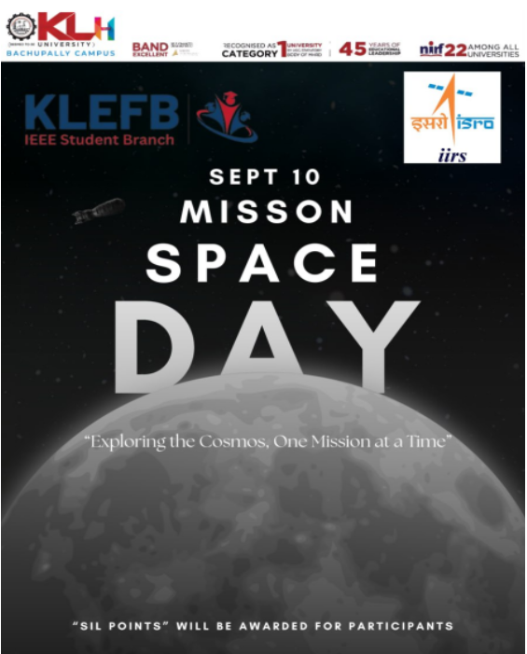

Conclusion:
Mission Space Day was an exciting and educational experience that deepened my appreciation for space exploration and scientific innovation. The event inspired me to think beyond boundaries and understand the value of curiosity and teamwork in achieving great discoveries.

Acknowledgment:
Special thanks to KLH University and the Department of Science and Humanities for organizing Mission Space Day and providing a platform for students to explore the wonders of space and science.

